OSTIn project: Developing the framework
Mahmud Muhammad, Susanna Jenkins
March 1st, 2025

Summary:
This report outlines the OSTIn project's framework for forecasting and updating Eruption Source Parameters (ESPs) using probabilistic methods and various data sources.
- Project Objective The project aims to develop probability density functions to describe inputs required by the NAME model at different timesteps, including location, time, plume height range, and duration.
- Phases One and Two Phase one involved creating Python scripts to sample key input parameters based on eruption size probabilities. Phase two focuses on automating infrasound and satellite imagery analyses to update ESP distributions.
- VONA Messages The system parses VONA messages from MAGMA and TVAAC to update ESPs in real-time. If Ash cloud provided in flight level instead of Height above ground level the Python scripts automatically convert ash cloud data from flight levels to height above ground using the SRTM dataset.
- The developed Python codes will be available via the following GitHub Link
Table of Contents
Summary: 1
Introduction: 2
1.Extract Volcano Observatory Notice for Aviation (VONA) Messages 3
2. Initialize and Sampling Eruption Source Parameters (ESP) 4
• Initiate Eruption source parameters based on probabilistic VEI levels based on Whelley et al.,2015 database where only Volcano location and name is known. 5
• Sampling ESP parameters from observed Plume Height (from infrasound/satellite) 12

Introduction:
The objective of this part of the project is to develop a suite of probability density functions that describe the inputs required by the NAME model at three timesteps:
- First VONA: Only location and time are known.
- Infrasound data: Plume height range and duration are also known.
- Satellite data
Phase one of this project focused on the deliverables for timestep 1. We have developed several Python scripts to stochastically sample the key input parameters: mass eruption rate, duration, and plume height and grain size distribution. These parameters are weighted by the probability of different eruption sizes (VEI), based on data from Whelley et al., (2015).
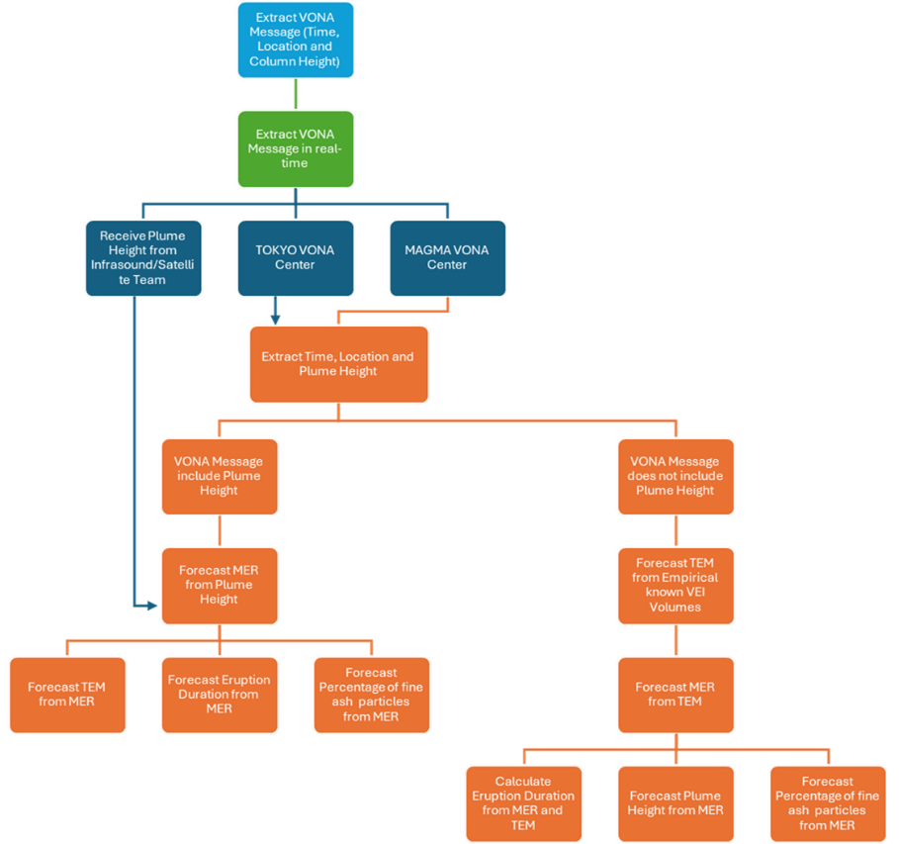
In the current report here described as phase two of the project, we Developed software to automatically launch infrasound and satellite imagery analyses using the time and location provided by a VONA (Volcano Observatory Notice for Aviation). Subsequently, update eruption source parameter distributions based on the outputs of the updated VONA messages, infrasound and satellite imagery analyses.
The flow chart (Fig. 1) explains the working methodology steps to continuously forecast and update eruption source parameters (Plume height, Mass Eruption Rate, Total Erupted Mass, ratio of fine ash particles, and Eruption Duration) in real-time as new data becomes available from various sources including updated VONA messages, infrasound and satellite imagery.
Figure 1. Flow chart explains methodology steps to forecast and update Eruption Source Parameters.
Furthermore, once the location and name of the volcanic eruption site retrieved, we are using the Whelley et al. database to assess the potential VEI volcanic eruption. ​The volcanic database developed by Whelley et al. (2015) is a comprehensive compilation of active and potentially active volcanoes in Southeast Asia. This database includes detailed information on approximately 750 volcanoes, encompassing aspects such as their morphology, eruption history, and potential hazards. The primary objective of this database is to enhance the understanding of volcanic activity in the region, thereby improving hazard assessments and informing disaster preparedness strategies. Whelley et al. analyzed the frequency and magnitude of explosive volcanic eruptions in Southeast Asia, providing insights into eruption patterns and potential impacts.

1.Extract Volcano Observatory Notice for Aviation (VONA) Messages
This step involves continuously parsing VONA messages using our in house developed python scripts which parses data from two different VONA centers including Multiplatform Application for Geohazard Mitigation and Assessment in Indonesia (MAGMA) and Tokyo Volcanic Ash Advisory Center (TVAAC). The user has the option to send requests to download new VONA messages within defined time intervals for instance every 10 minutes. Consequently, the developed python codes parse the data and inform the user for any changes happening within the VONA messages. Once the system detected changes within the VONA message such as plume height then the new information will be stored to update forecasting the reminder of the ESP parameters including mass eruption rate, total eruption mass, eruption duration and percentage of fine ash particles.
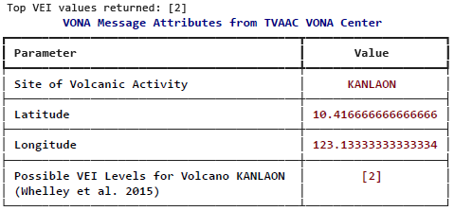

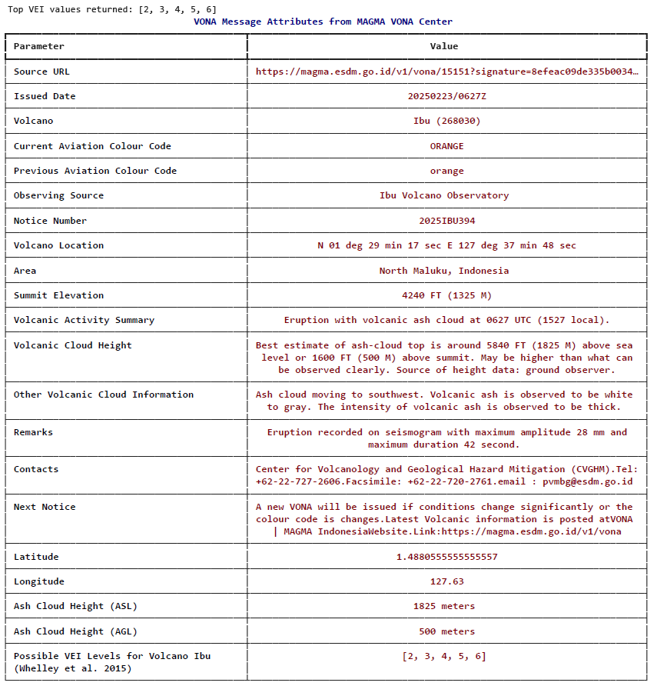
The above table shows important processed VONA message parameters parsed from TVAAC. It worth to mention that TVAAC VONA messages is less descriptive compared to MAGMA VONA messages and need further processing for instance TVAAC message presents ash cloud using aeronautical code flight level which requires conversion to height above the ground. Our python script automatically converts ash clouds from flight levels to ash cloud above the ground (vent level) using open-source Shuttle Radar Tomography Mission SRTM digital elevation dataset. As shown in the flow chart of figure 1 in case of lack of ash cloud information, we use information from potential VEI level for the given volcano site based on the Whelley et al., 2015 database to start forecasting and sampling eruption source parameters.

2. Initialize and Sampling Eruption Source Parameters (ESP)
The sampled eruption source parameters will be updated whenever new data becomes available. Below we provide sequential probabilistic forecasting of eruption source parameters steps with figures.

Initiate Eruption source parameters based on probabilistic VEI levels based on Whelley et al.,2015 database where only Volcano location and name is known.

- Sample Total Erupted Mass (TEM) from VEI and Volume
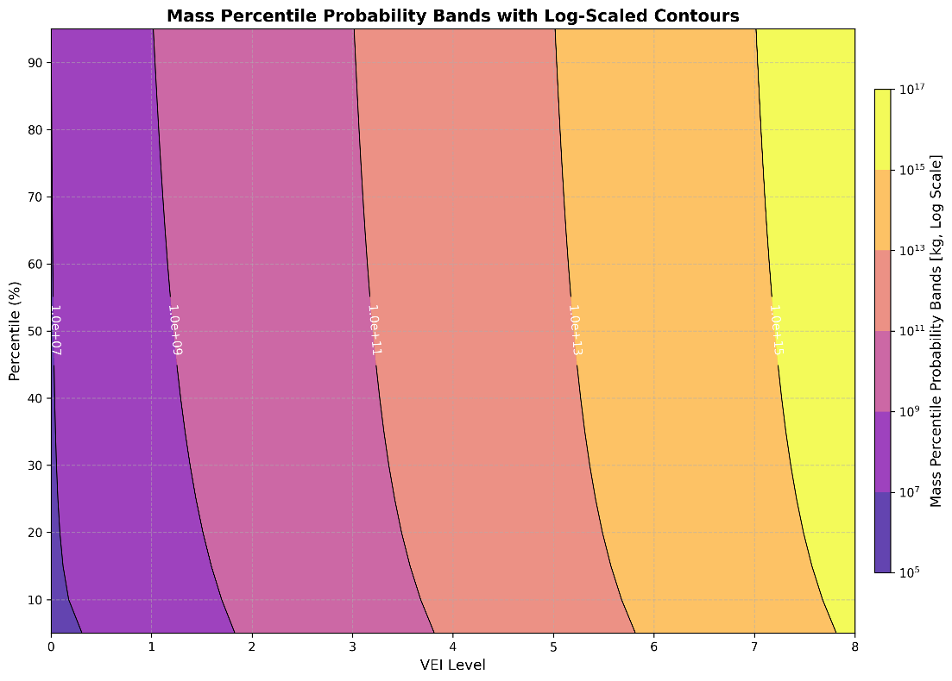
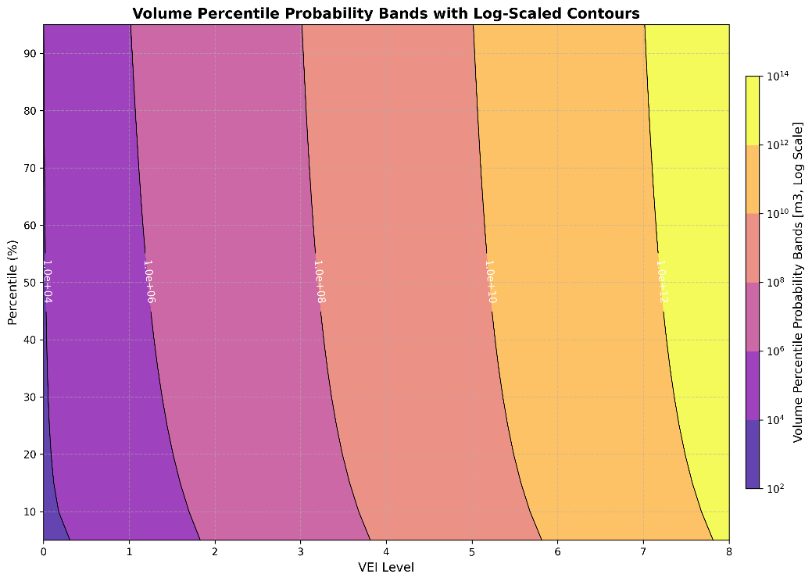

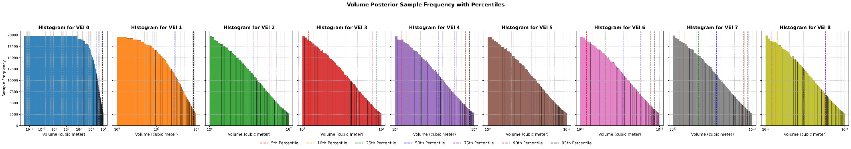

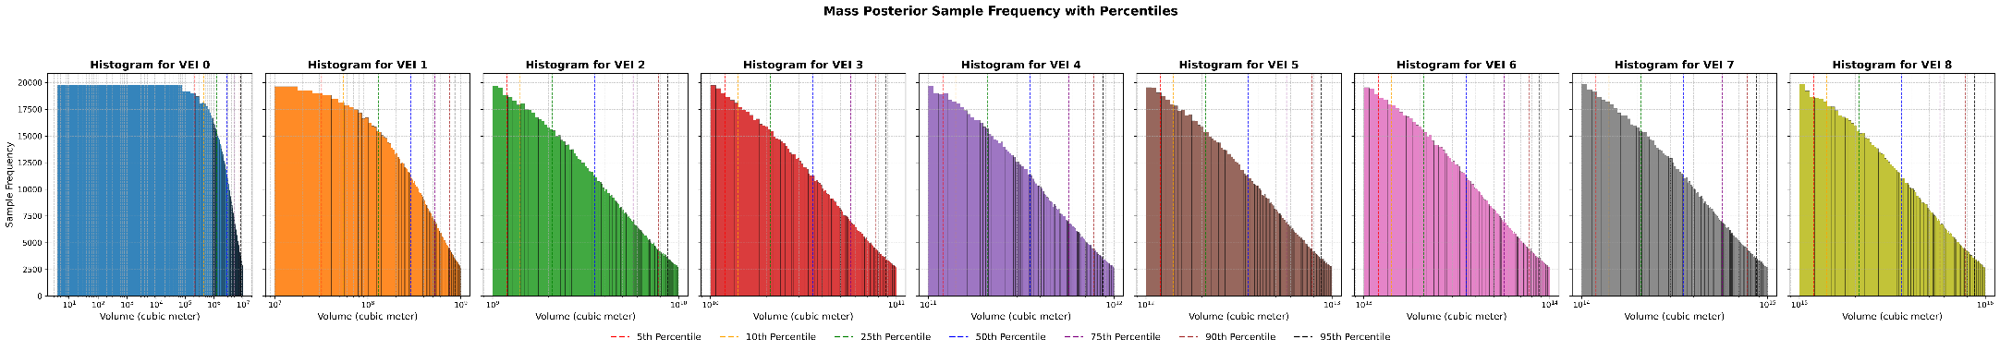

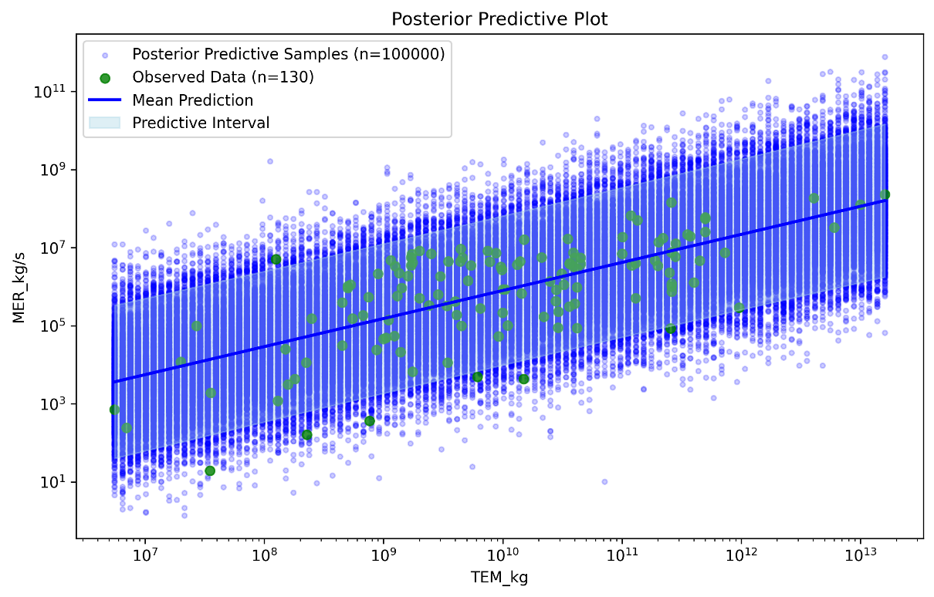
- Sample Mass Eruption Rate (MER) from TEM and calculate Eruption Duration
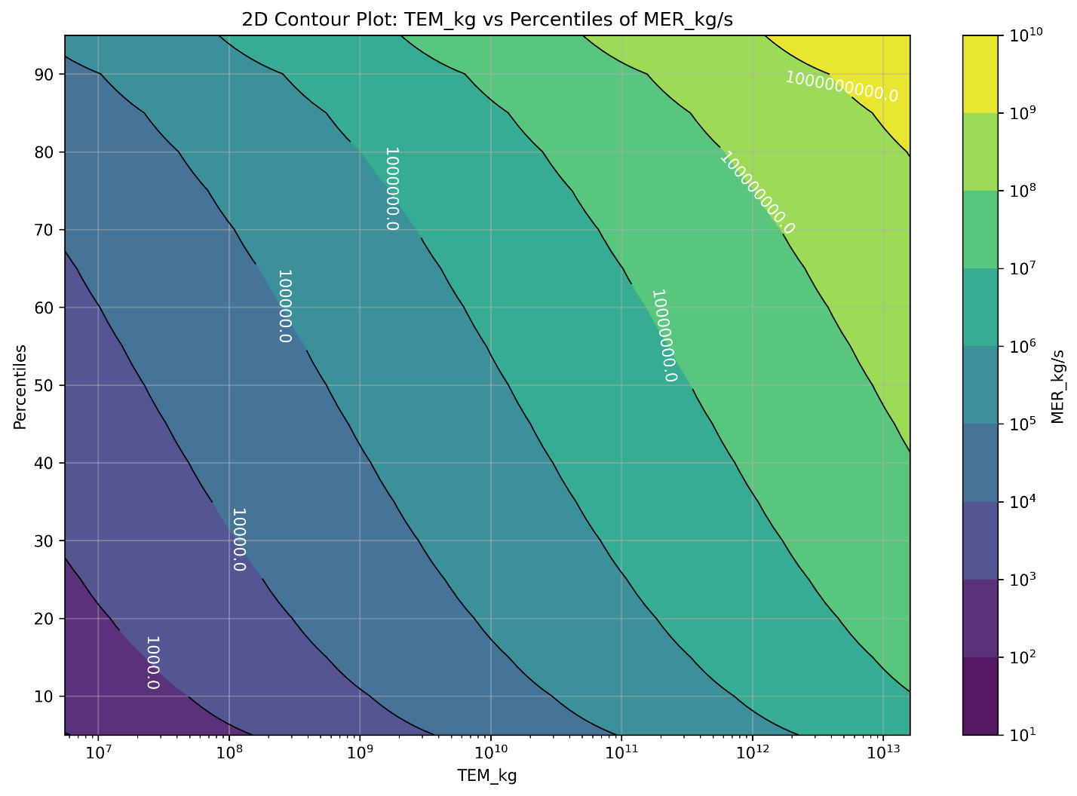
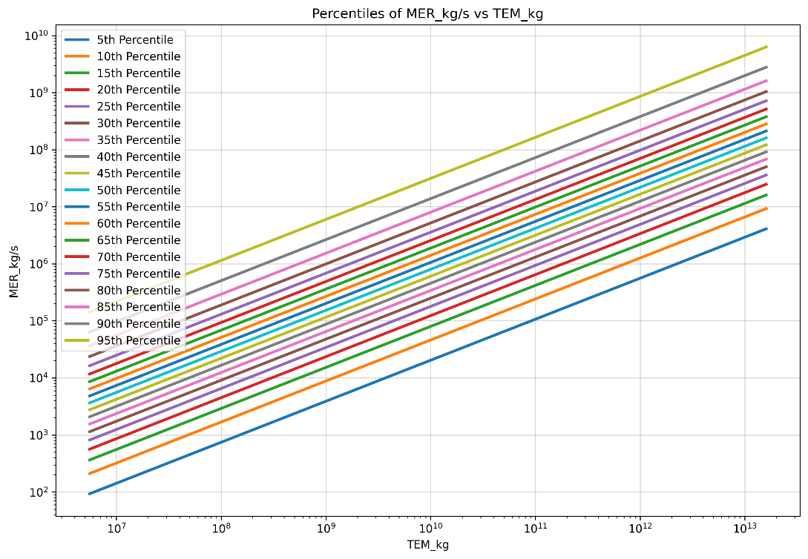

- Sample Plume Height from Mass Eruption Rate (MER)
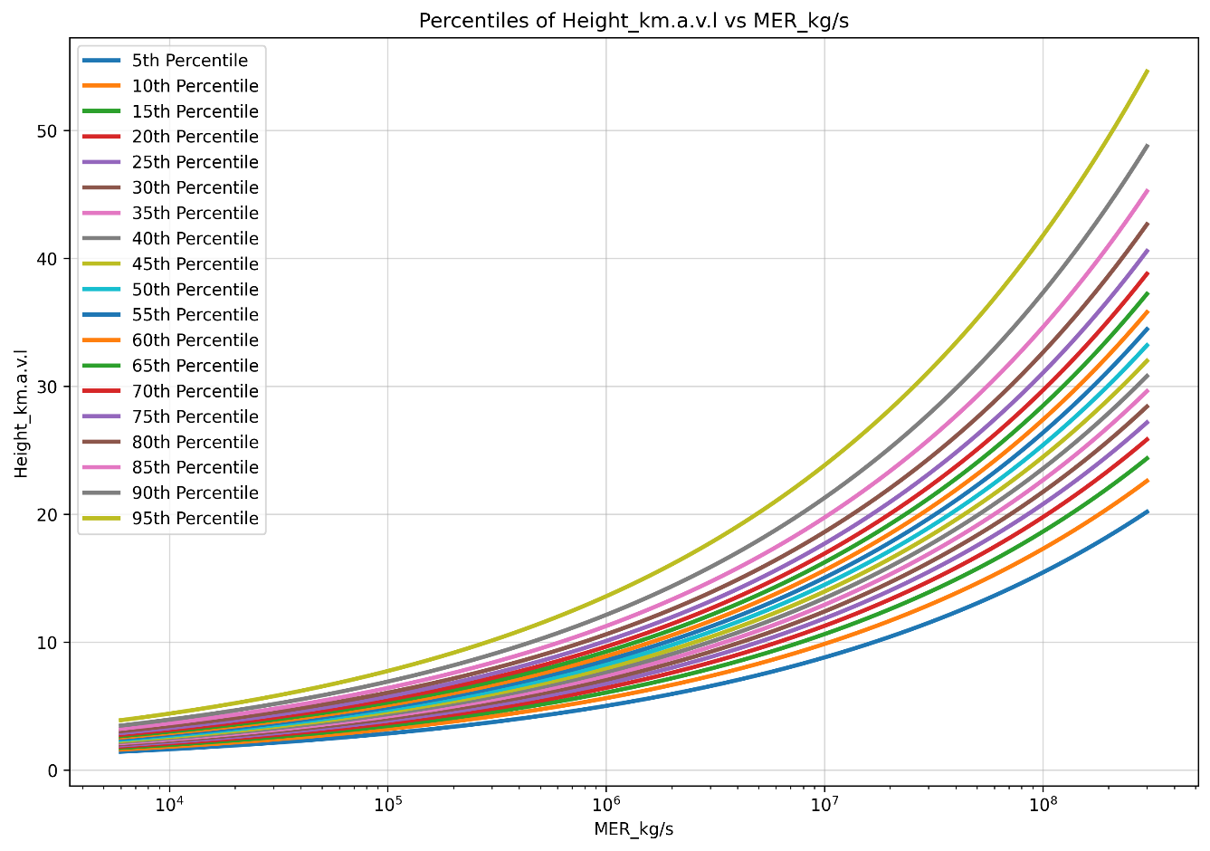
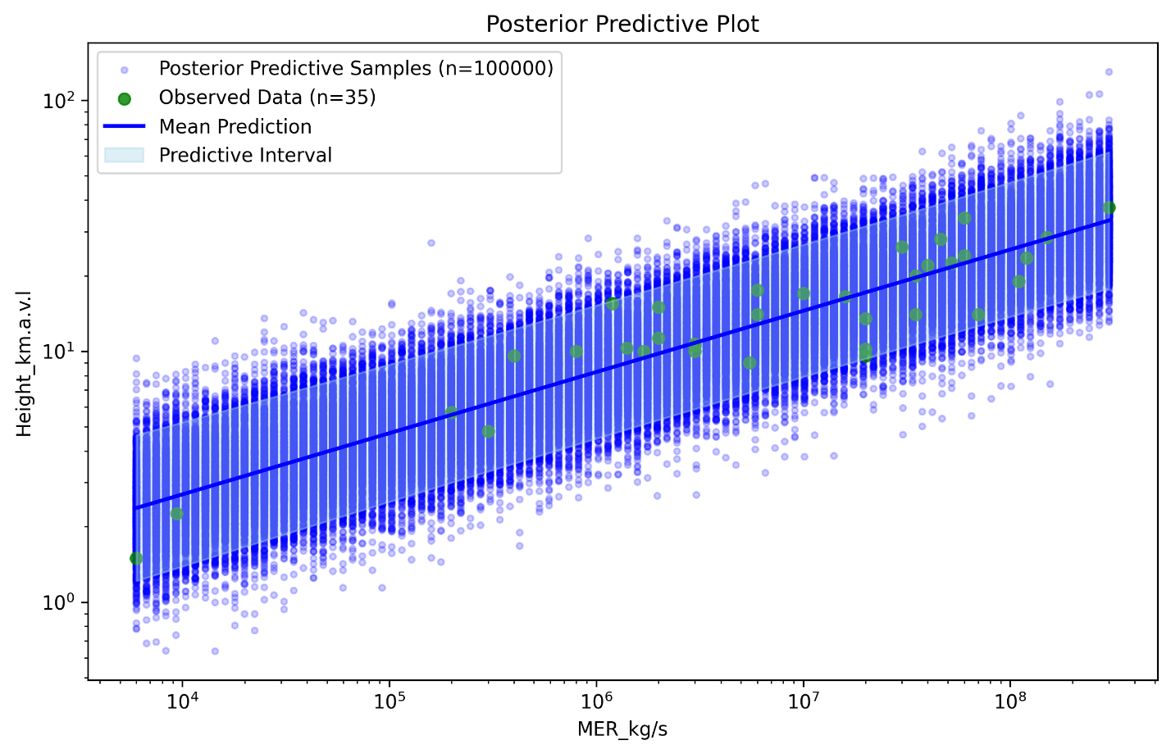
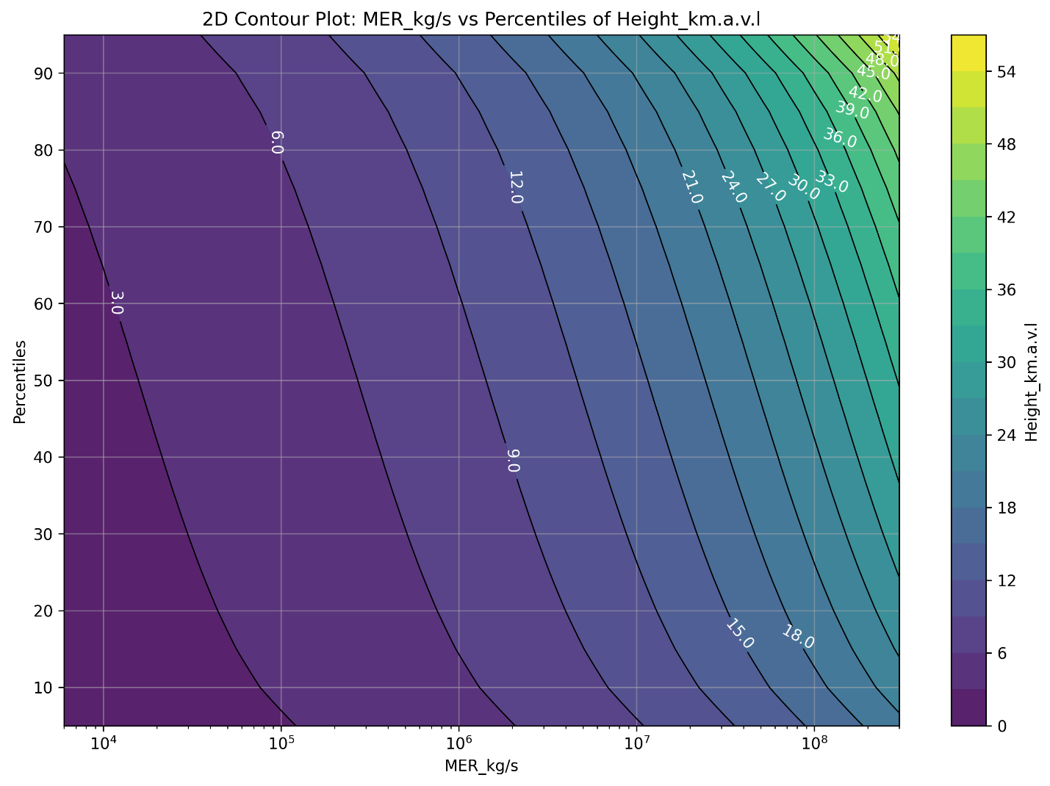
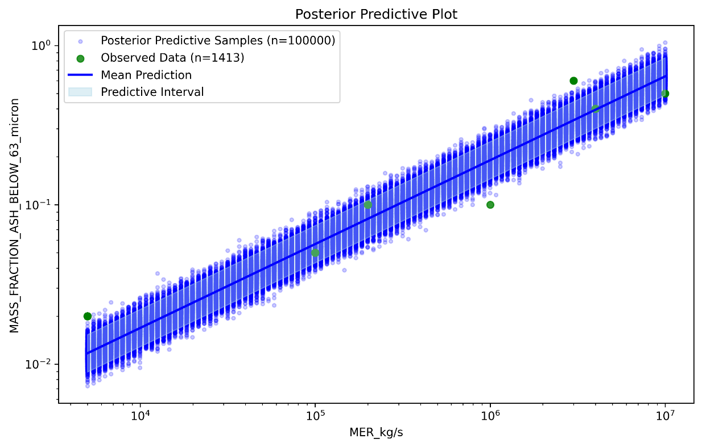
- Sample fine ash particle size from Mass Eruption Rate (MER)
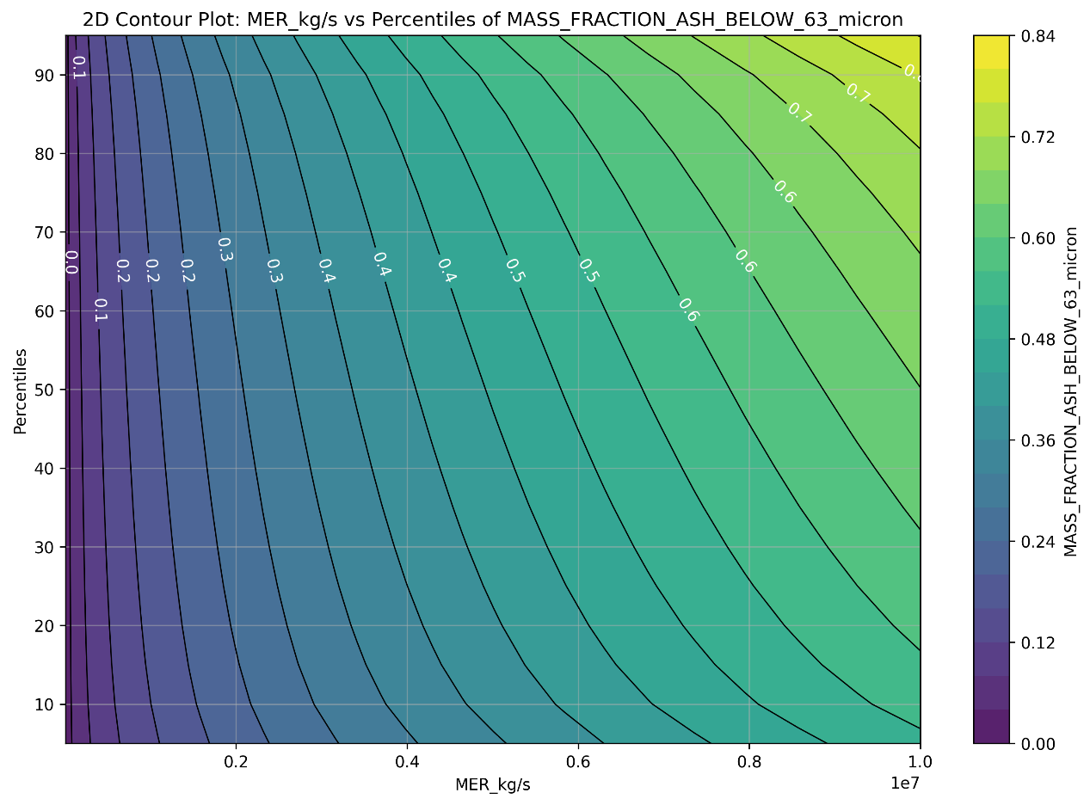
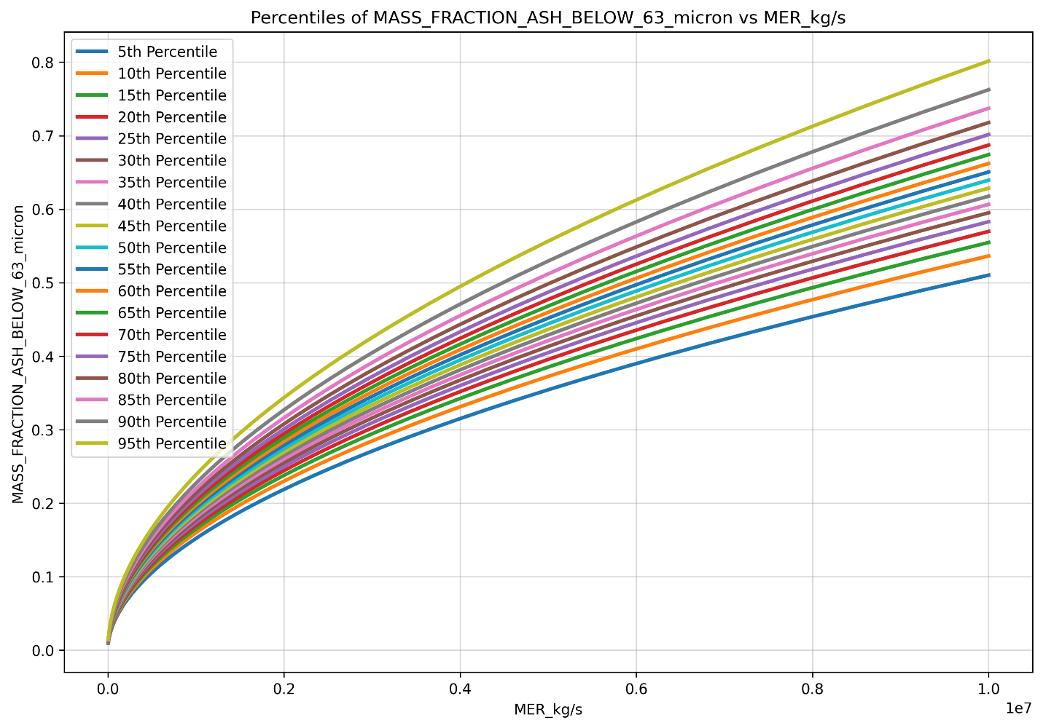
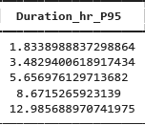
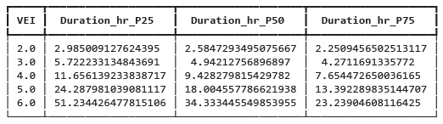
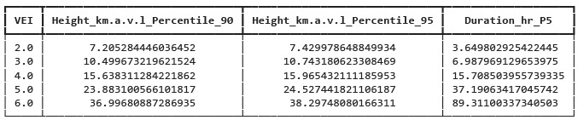
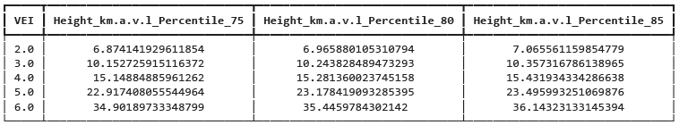
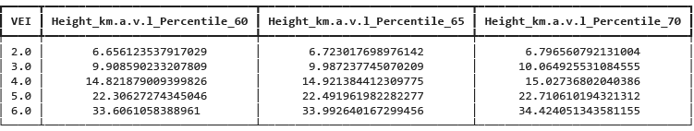
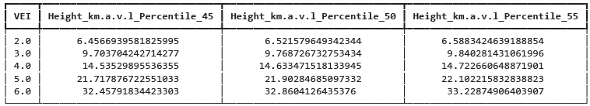
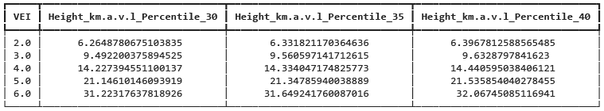
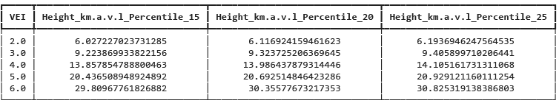
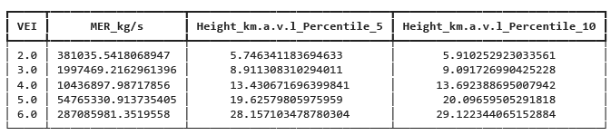

Sampling ESP parameters from observed Plume Height (from infrasound/satellite)

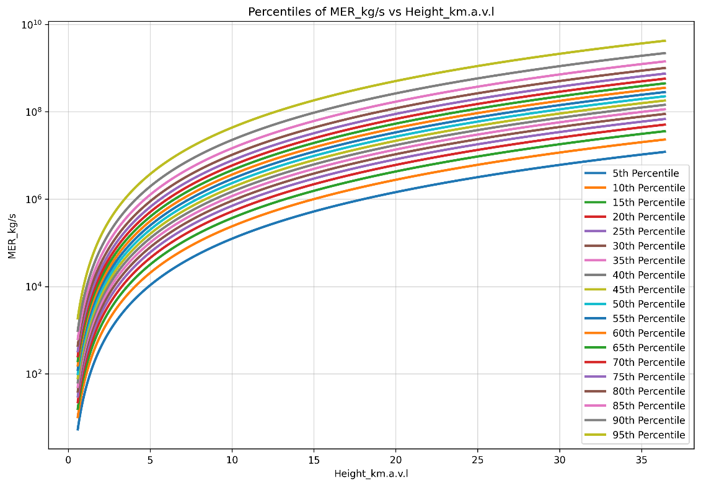
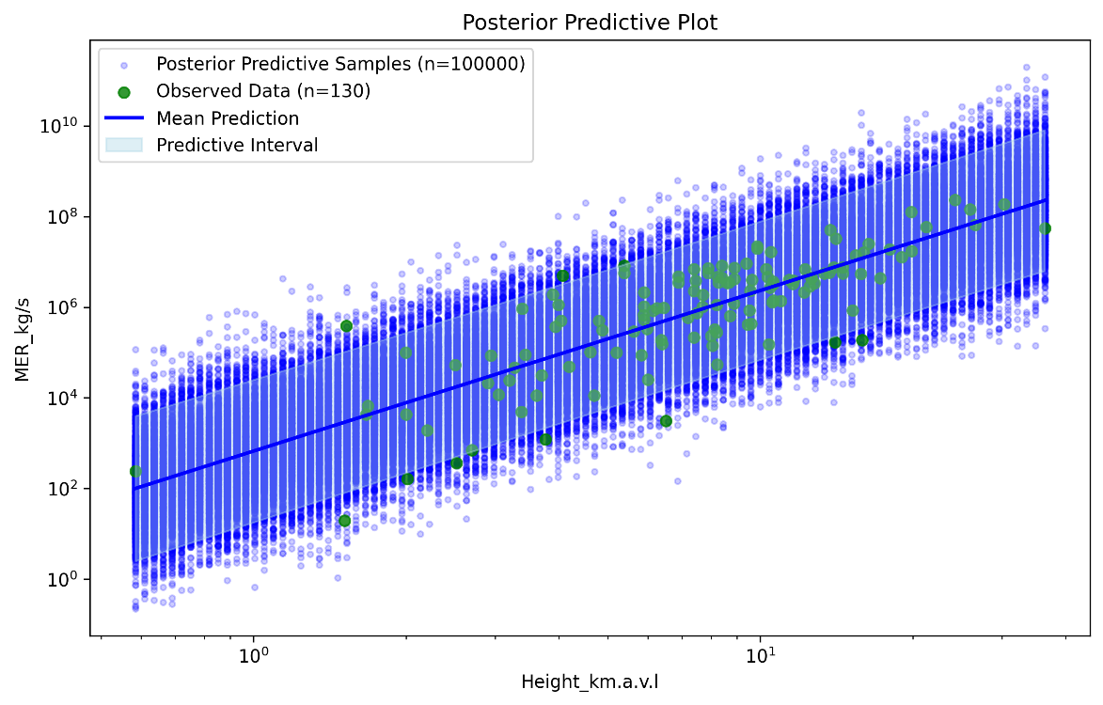
- Sampling MER from Plume Height

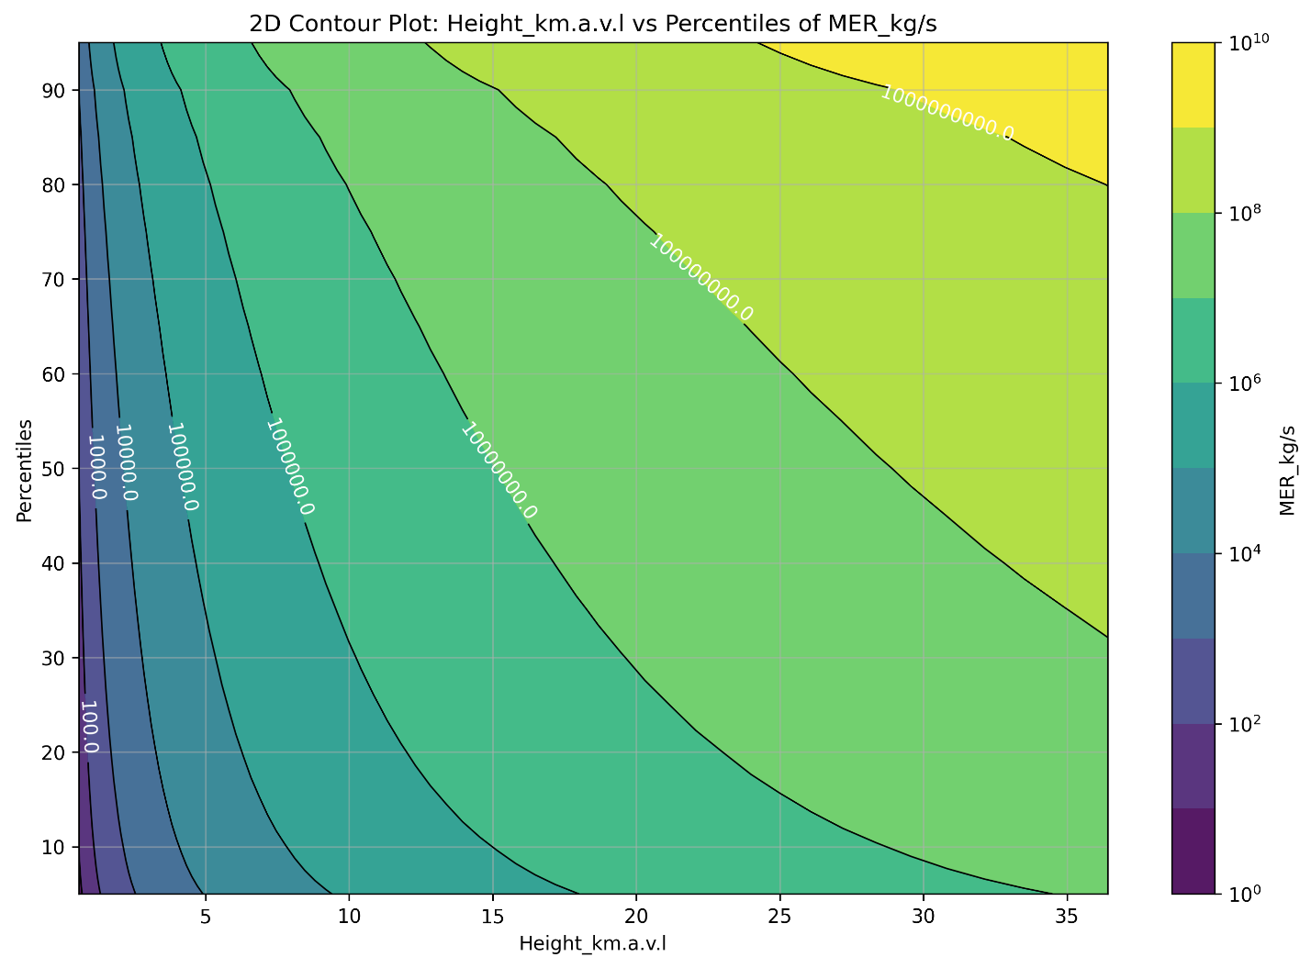

- Sampling TEM from MER
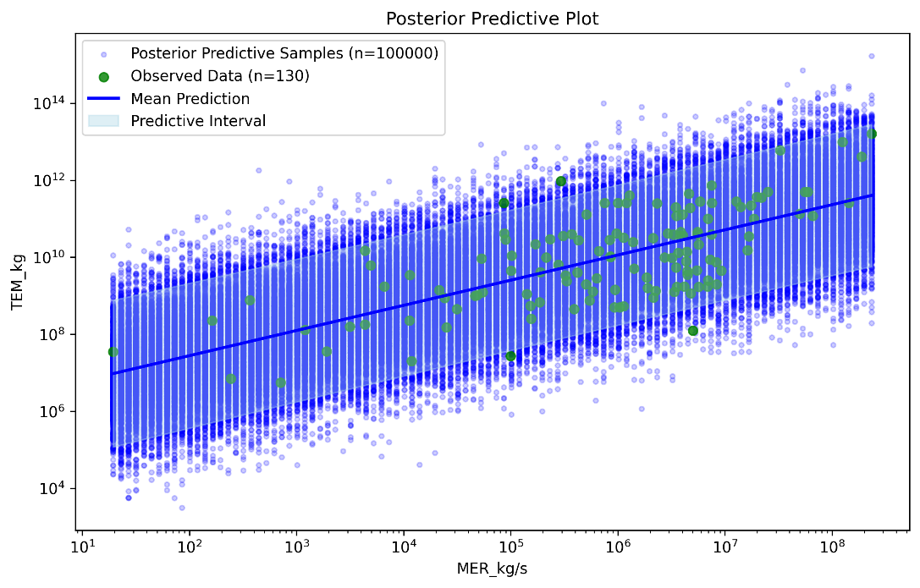
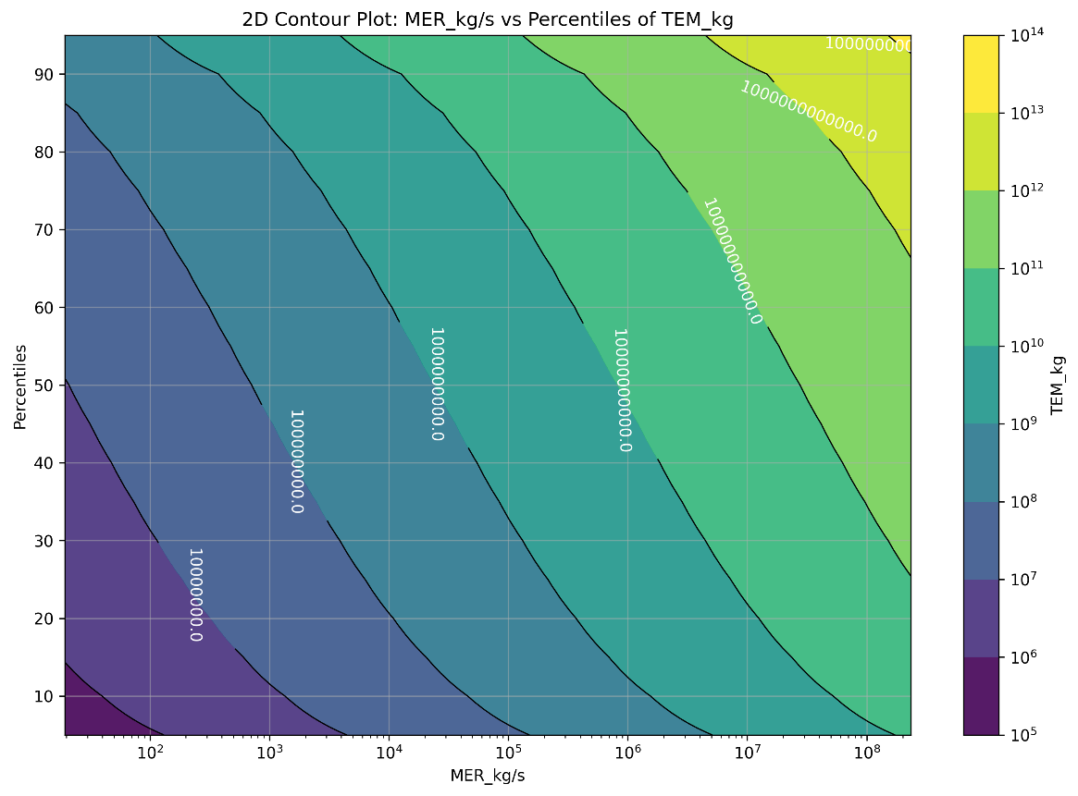
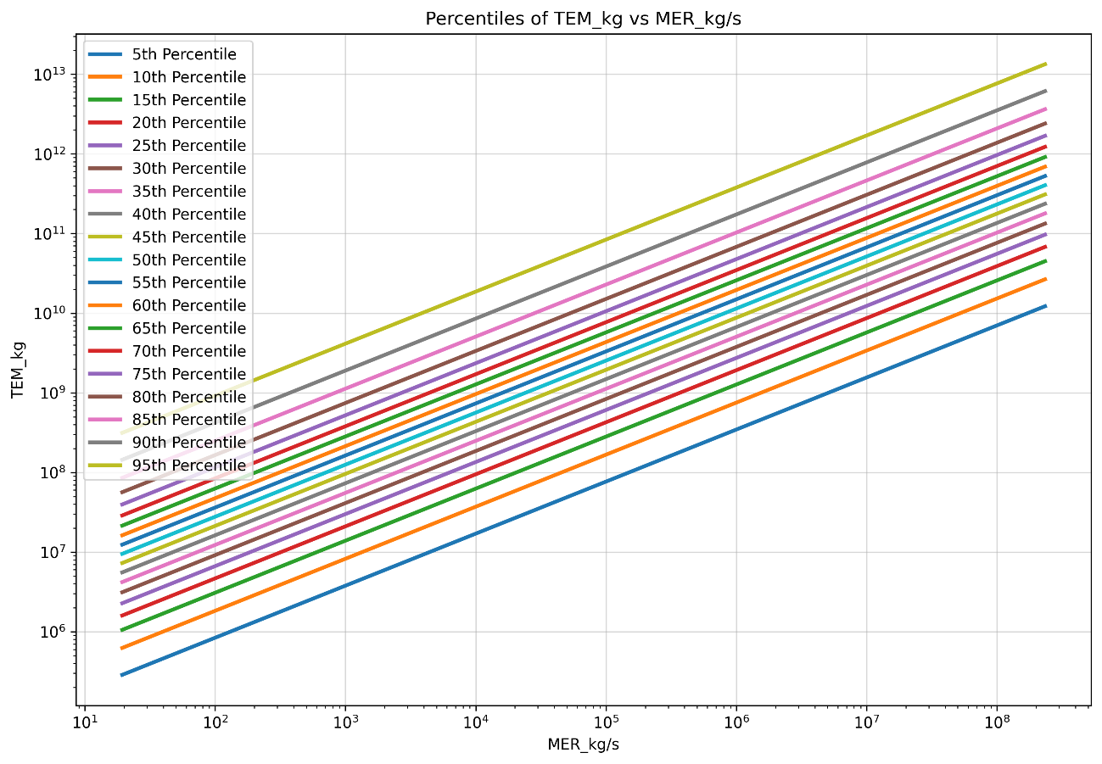

- Sample Eruption Duration directly from MER
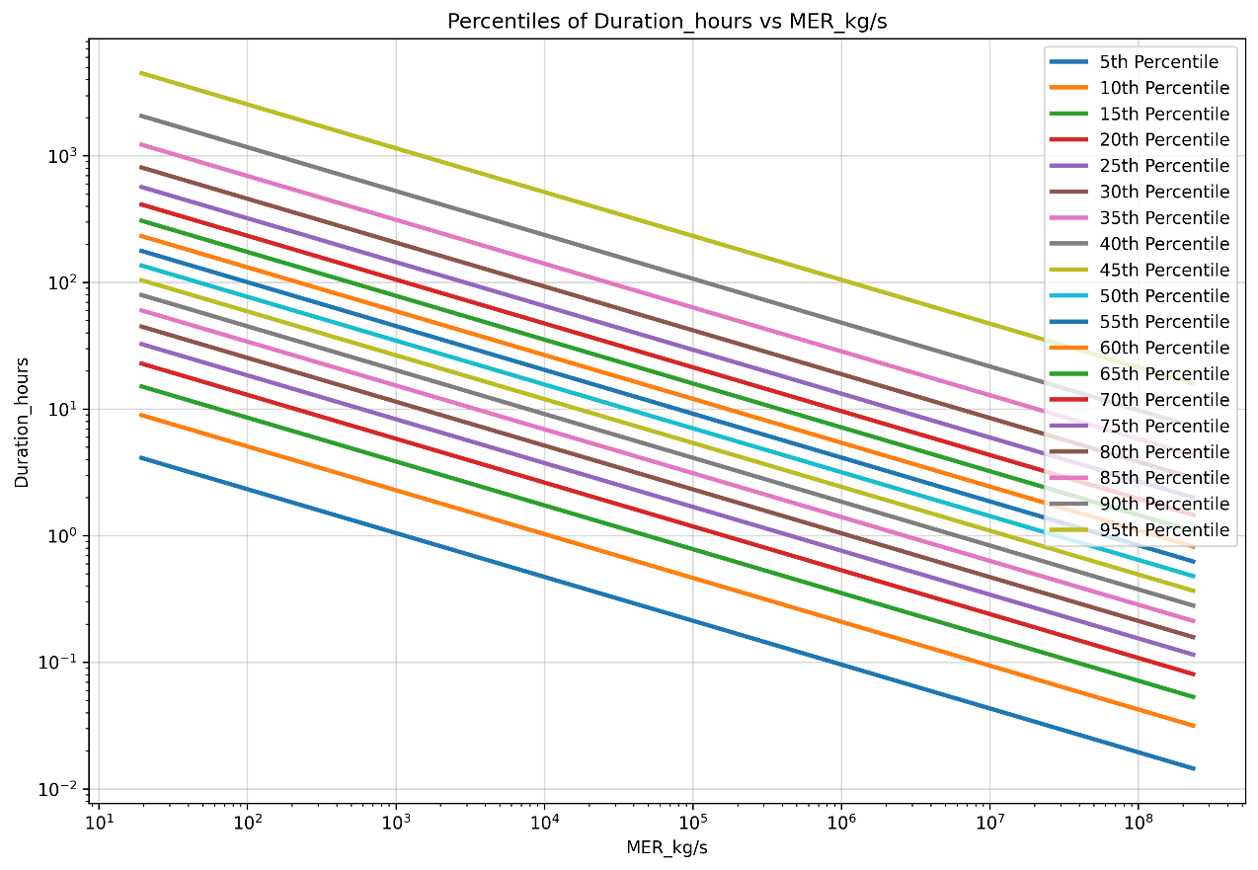
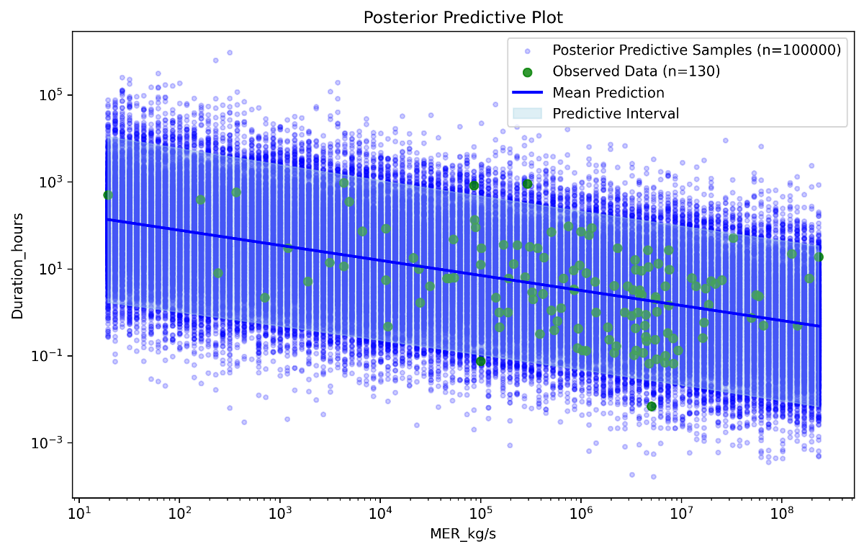

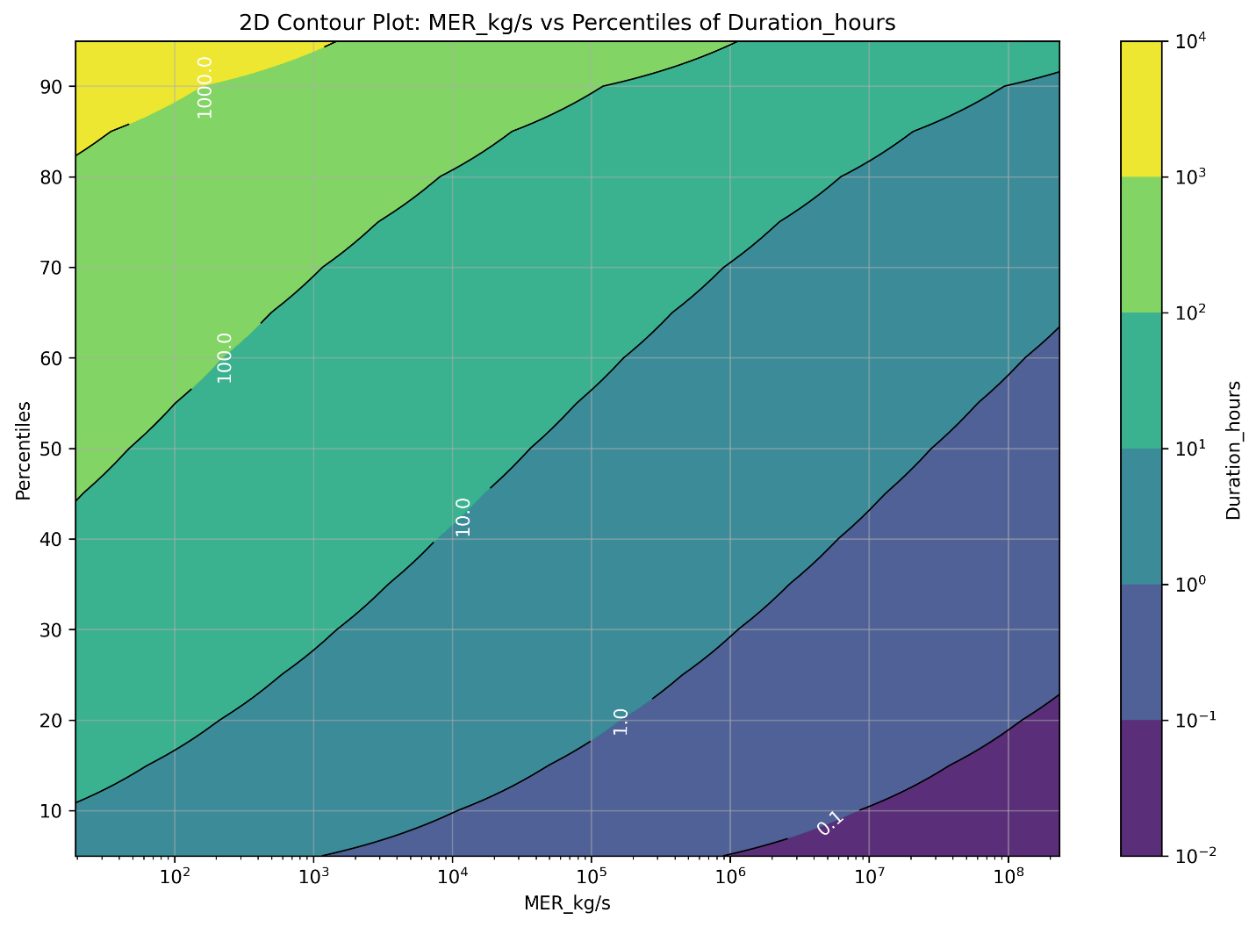
- Sample fine ash particles from MER
